**Step 1: Conduct search of Certifications.**

Use your favorite search engine to conduct a search for the most popular cybersecurity-related  
certifications. List them below with the organization that provides the certification.  
1. CEH: Certified Ethical Hacker by E Council  
2. CISM (Certified Information Security Manager)  
3. CompTIA Security+  
4. CompTIA Advanced Security Practitioner (CASP)  
5. CISSP (Certified Information Systems Security Professional)  
6. GSEC: GIAC Security Essentials  
7. CCNA by Cisco

b. Pick three certifications from the list above and provide more detail about the certification requirements and knowledge gained i.e.: vendor specific or neutral, number of exams to gain certification, exam requirements, topics covered etc.

|  |  |  |  |
| --- | --- | --- | --- |
| **Certification** | **Cost** | **Prerequisites** | **Best For** |
| CEH: Certified Ethical Hacker (CEH) | $950-$1,199 | 2 years of experience in information security; graduates of EC-Council training | Programmers interested in penetration tester roles. |
| CISM: Certified Information Security Manager (CISM) | $575 for members; $760 for non-members | 5 years of experience in a managerial role related to information security | Programmers interested in solidifying their managerial experience |
| CompTIA Security+ | $381 | 2 years of IT security experience recommended, but not required | Aspiring cybersecurity professionals just beginning their careers |

**Step 2: Investigate positions available within cybersecurity**

Glassdoor is one of the largest job sites worldwide. Using your browser of choice, access glassdoor.com and search to find cybersecurity jobs available that were posted within the last two weeks. Adjust the search as you would like. You can search for jobs in your area or an area that you would like to live and work in.

Questions:

a. How many new job listings were posted within the last two weeks?

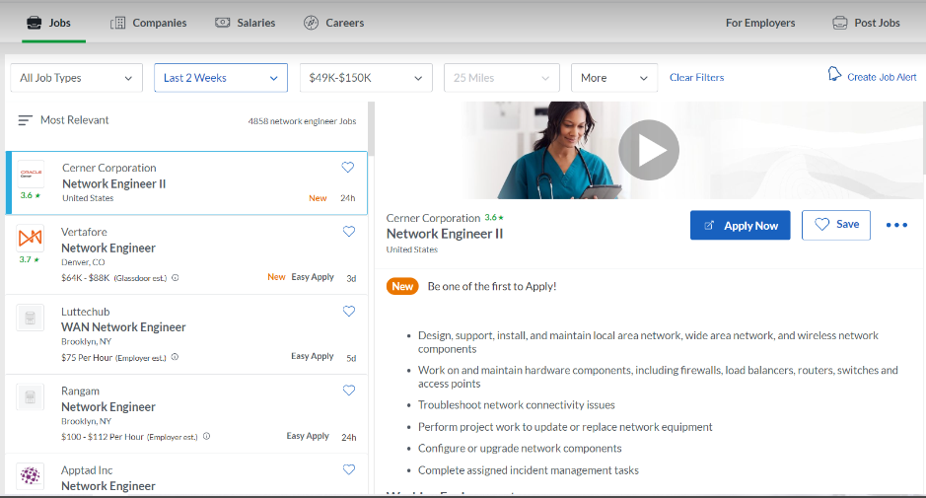

b. What is the salary range for the top 10 listings?



c. What are the most common qualifications required by employers?  
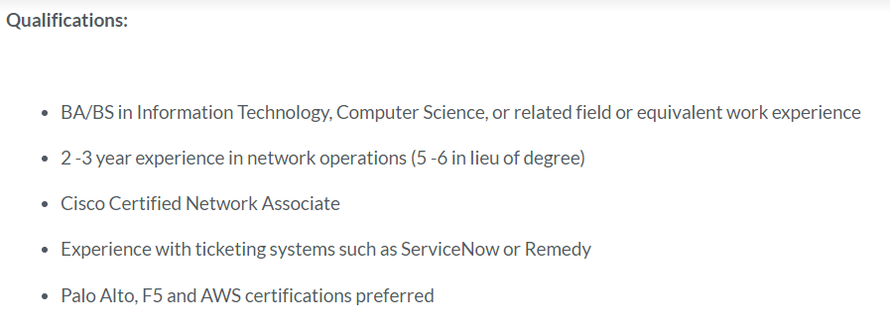

d. What industry certifications are required by these employers?  
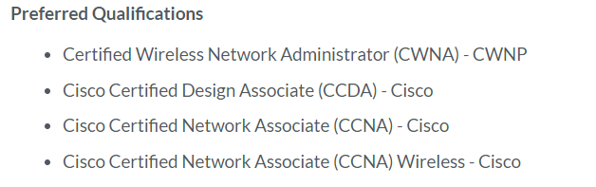

e. Do any of the certifications match the ones that you found in Step 1a?

Yes, we have CCNA

f. Investigate online resources that allow you to legally test your hacking skills. These tools allow a novice with limited cyber security experience to sharpen their penetration testing skills. One such site is Google Gruyere (Web Application Exploits and Defenses). What kinds of challenges can you find?